LAB 2
Web Application Security Testing
DVWA and Mutillidae – Burp Suite, file-upload validation, Nikto, DIRB and SQL injection

Student: Ayodele Banjo
Student ID: C11/26/FCDF/17169

Summary
This report covers the web application testing I carried out on DVWA and Mutillidae, both running on the Metasploitable2 VM at 192.168.56.101. I looked at how HTTP requests are put together, checked session cookies, tested the file-upload feature, ran Nikto and DIRB against the web server, and worked through the SQL injection exercises in Mutillidae — first by hand, then with SQLMap. I kept everything inside the boundaries the lab set: only harmless files for the upload testing, and I stopped SQLMap as soon as I had database and table names, without pulling any actual row data out.
Quick rundown of what came out of it. The HTTP baseline behaved normally — GET /dvwa/ came back 200 OK, and Burp picked up the same request. The upload form accepted both a .txt and a .log version of the same harmless file, and it even accepted an upload after I changed the Content-Type header to image/jpeg without touching the actual file content — the uploaded file was also reachable directly through the browser afterward, so weak validation plus web-accessible storage is a combination worth flagging. Nikto turned up an old Apache/PHP build, TRACE enabled, directory indexing, an exposed phpinfo.php, and a few missing security headers. DIRB found 42 paths in total, including phpMyAdmin, a /test/ directory and some Twiki content. On the SQL injection side, a single quote in the Mutillidae username field broke the query and threw a raw SQL error, and SQLMap went on to confirm boolean-based, error-based, time-based and UNION-based injection on that same username parameter.

Scope and Authorization
Everything here was carried out against the isolated lab VM at http://192.168.56.101 — DVWA at /dvwa/ and Mutillidae at /mutillidae/. I only worked through the exercises the lab guide approved, and for SQLMap I stopped as soon as I had database and table names; no row data was pulled out at any point.

Method
- Set a normal browser and proxy baseline first, before touching anything else.
- Test the upload form with harmless .txt and .log files to see how it handles extensions and MIME types.
- Run Nikto and DIRB to see what the web server itself gives away.
- Map out the Mutillidae inputs, then compare normal, malformed and true/false SQL responses.
- Verify one approved parameter with SQLMap and stop at metadata enumeration.

1. HTTP Baseline and Proxy Inspection
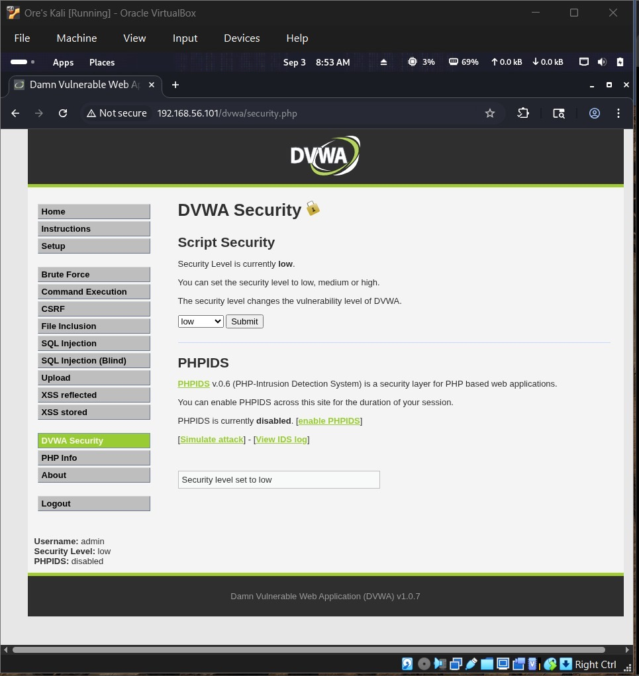
Figure 1. DVWA security level set to Low.
Setting security to Low just makes the app misbehave predictably for the exercise — it doesn't touch anything resembling a production setting.
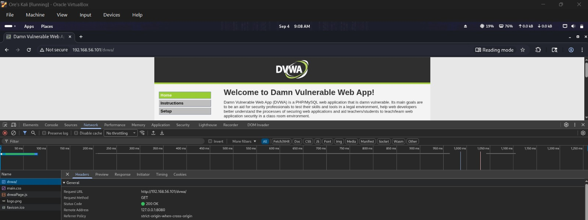
Figure 2. Browser Network panel showing the GET request and 200 OK.
The request came back as a plain GET with a 200 OK, which is exactly what a normal page load should look like.
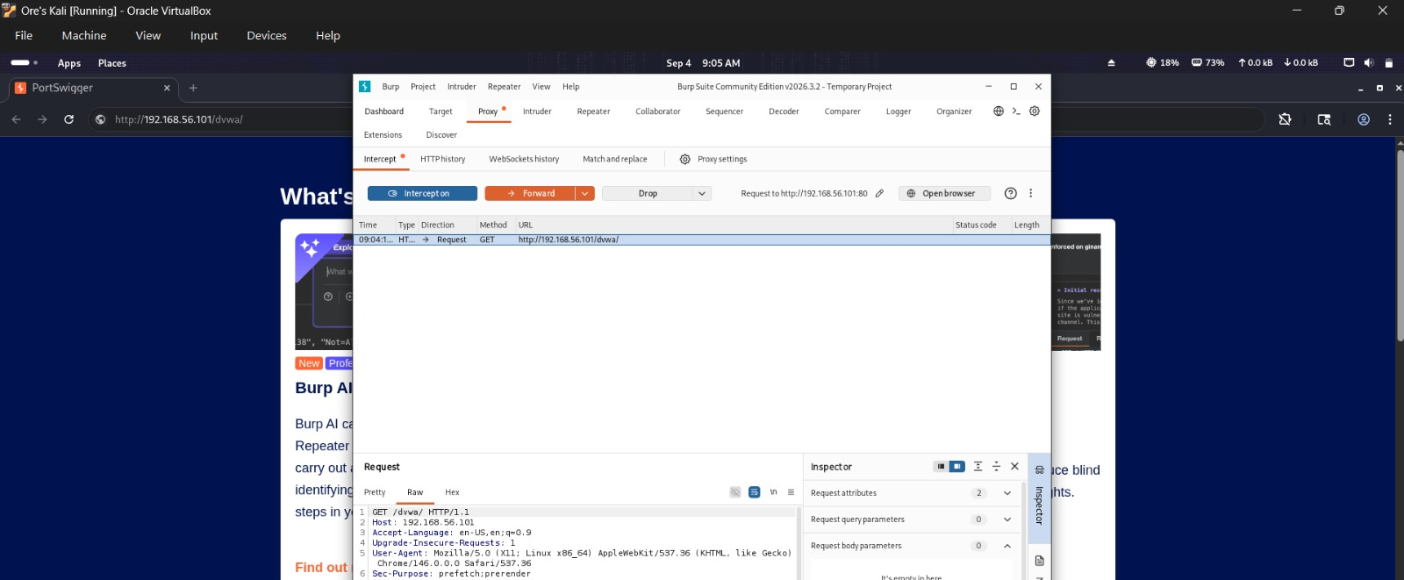
Figure 3. Burp intercepted the same GET /dvwa/ request.
Same request, caught this time in Burp — the request line and Host header are visible exactly as the browser sent them. This was just the baseline, not an upload.
The two cookies visible on this request were PHPSESSID and security. I'm not including the actual values anywhere in this report, since those are session secrets and not something that should end up in a document like this.

2. Harmless File-Upload Validation
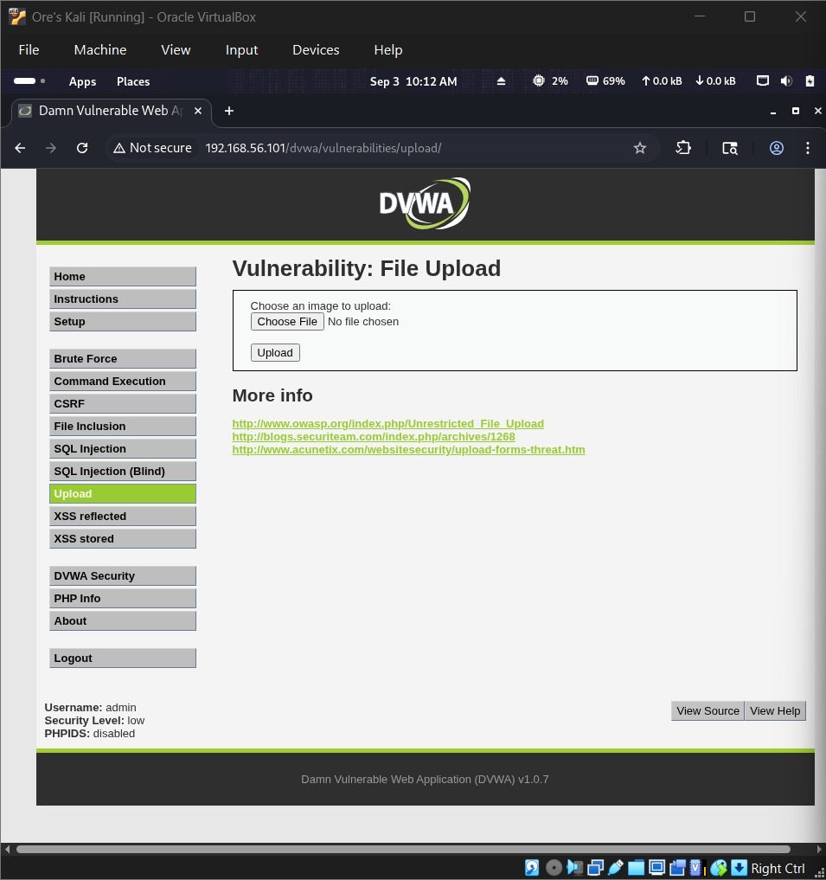
Figure 4. DVWA file-upload form.
This is the upload form — pick a file, hit Upload, and it reports back where the file ended up.
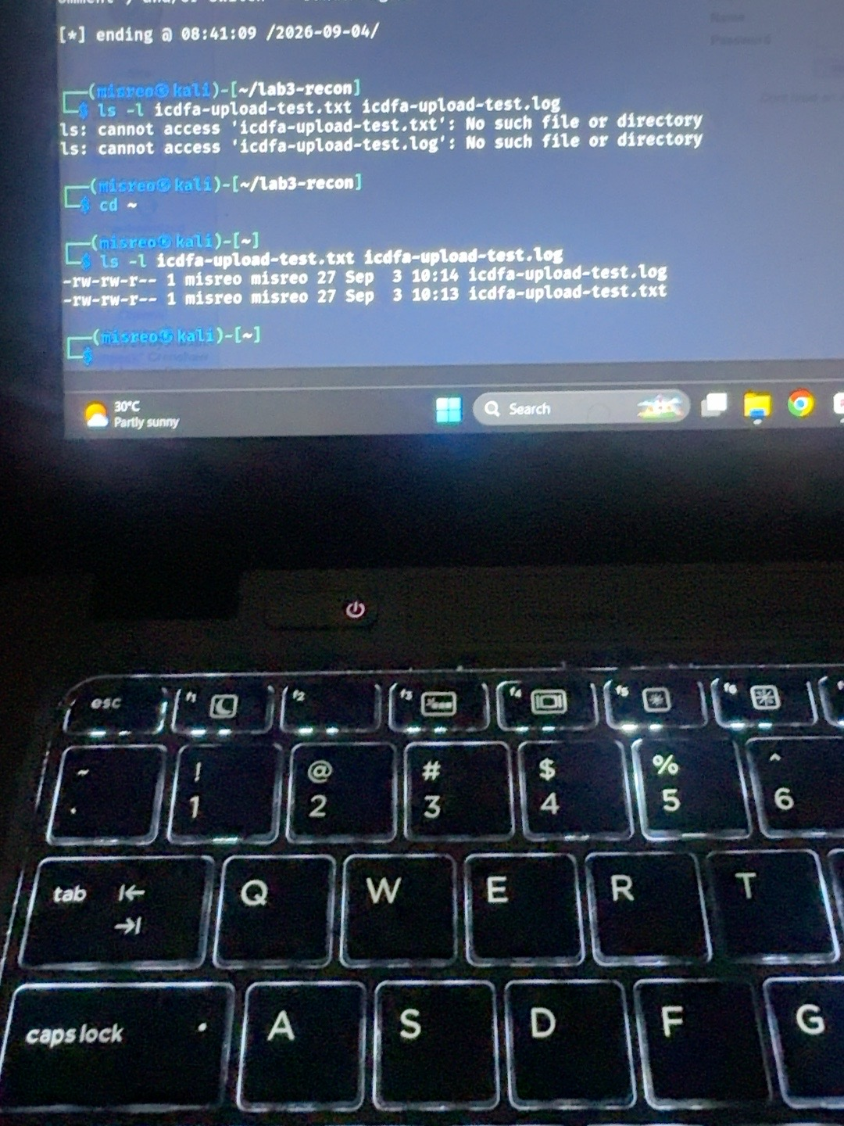
Figure 5. Harmless test files, 27 bytes each.
Both test files held the exact same 27 bytes of text — the only thing that changed between them was the extension, .txt versus .log.
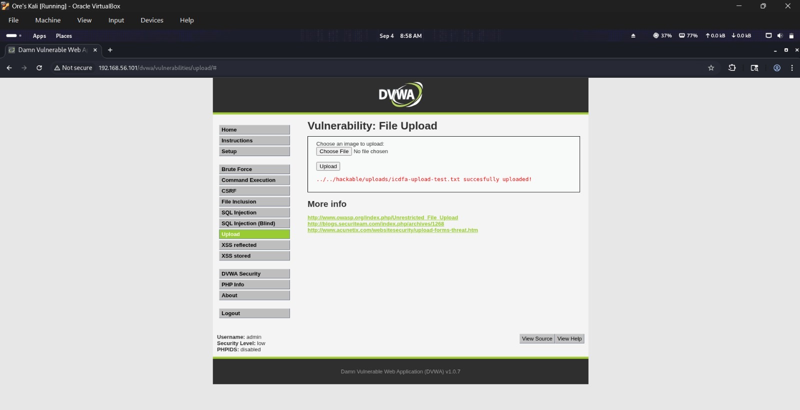
Figure 6. Normal .txt upload accepted.
The .txt version went through without complaint, and DVWA dropped it into ../../hackable/uploads/.
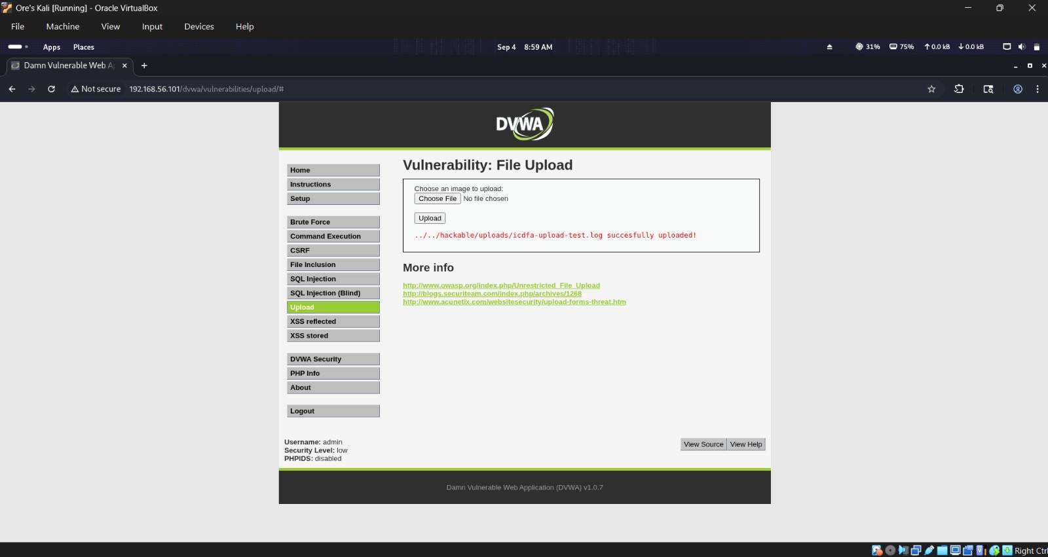
Figure 7. .log extension also accepted.
Just swapping the extension to .log didn't change anything — it got accepted too, which says the low-security handler isn't checking extensions against any kind of allowlist.
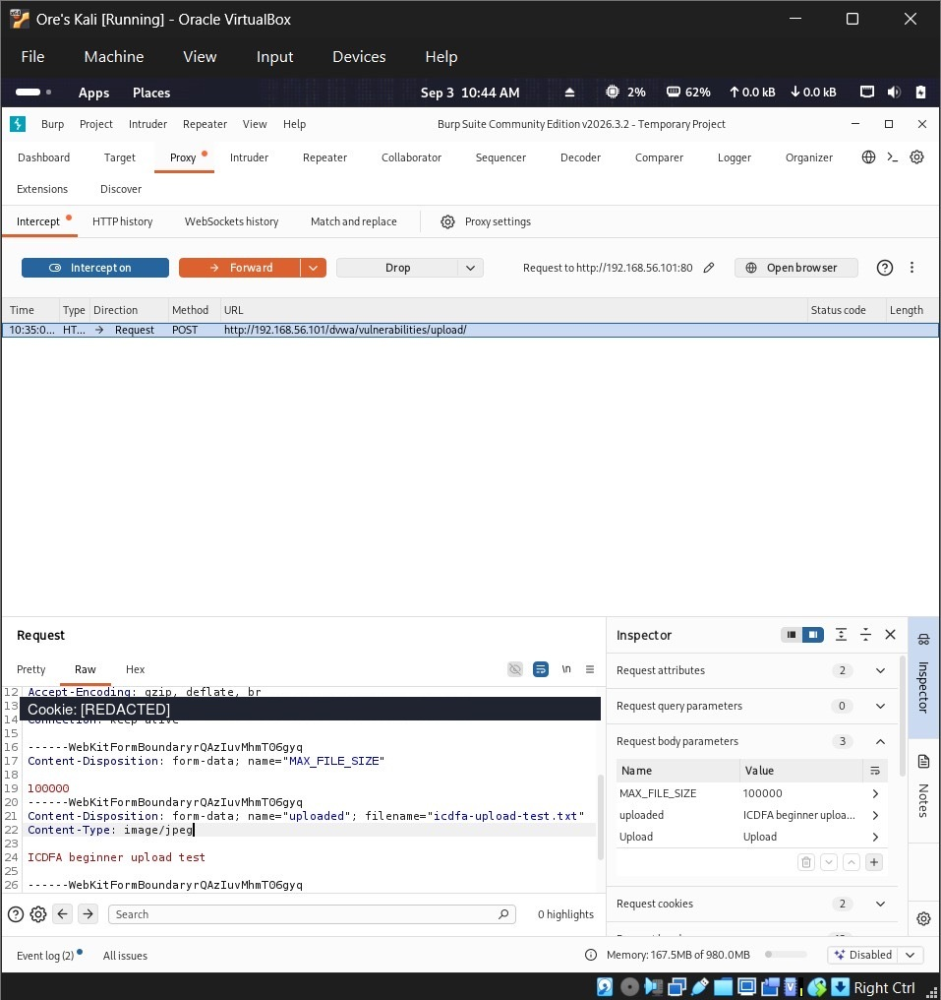
Figure 8. Intercepted multipart upload request.
Catching the upload in Burp shows the multipart body — the uploaded field name, the filename icdfa-upload-test.txt, and the Content-Type the browser attached. Cookie value blanked out here.
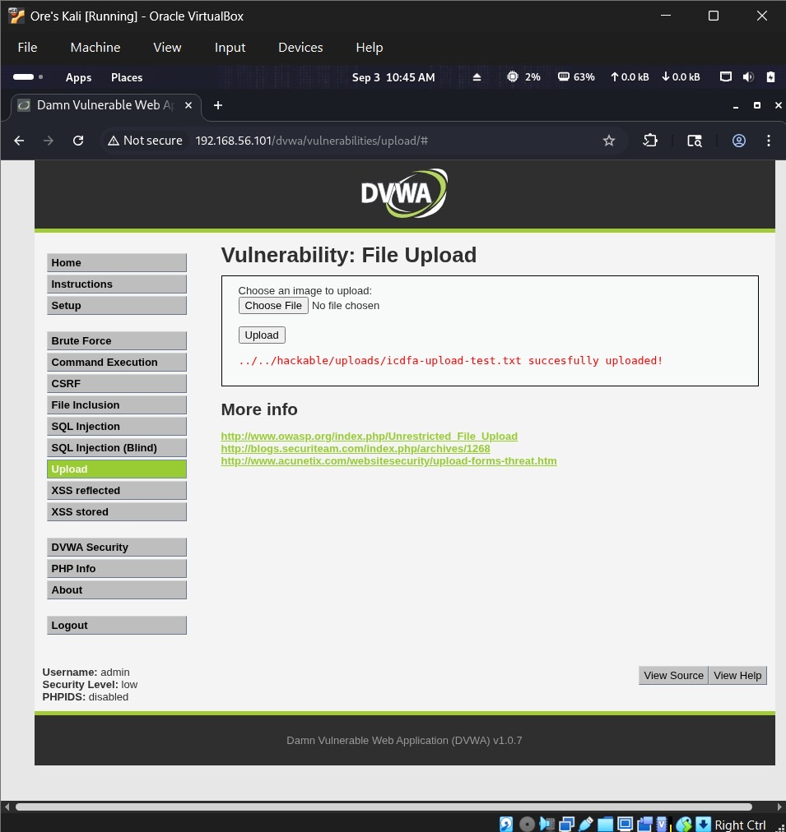
Figure 9. Upload accepted after the MIME label was changed.
I changed the Content-Type on that same request from text/plain to image/jpeg, didn't touch a single byte of the actual content, forwarded it, and it still went through. That's really the whole point of this test — the server is trusting a label the client controls, and there's no good reason it should.
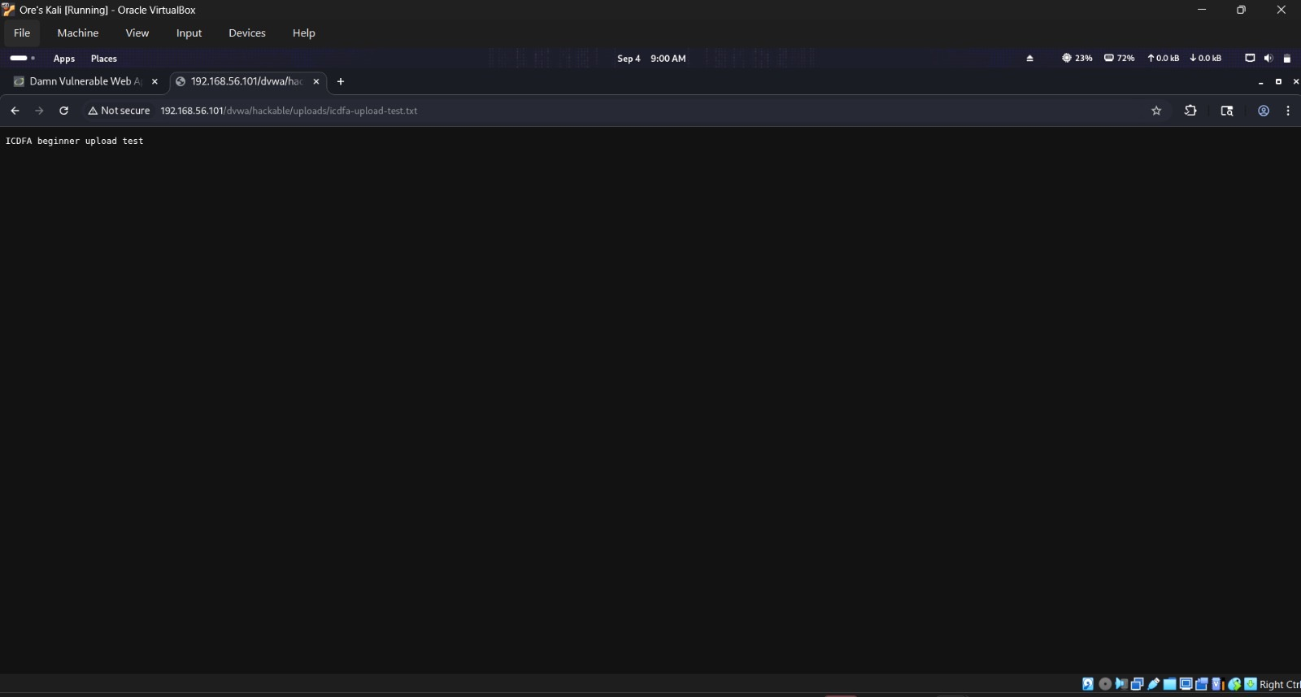
Figure 10. Uploaded file retrieved through the web path.
Opening the upload path directly in the browser pulled the text straight up, confirming the folder is reachable from the web rather than tucked away somewhere private.

3. Nikto Web-Server Assessment
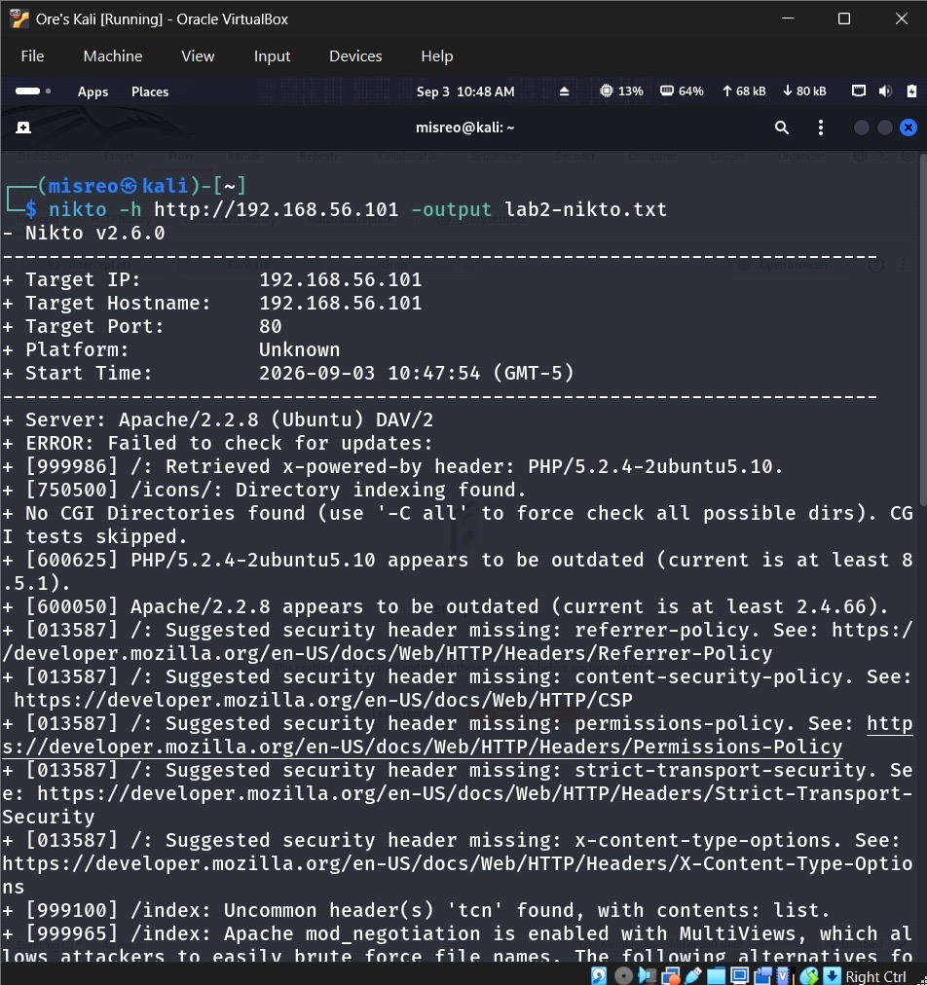
Figure 11. Nikto scan startup and initial findings.
Nikto started flagging things almost right away — Apache 2.2.8, PHP 5.2.4, and a few missing security headers. Worth remembering these are scanner observations, not automatically confirmed vulnerabilities — they still need a human to make sense of them.
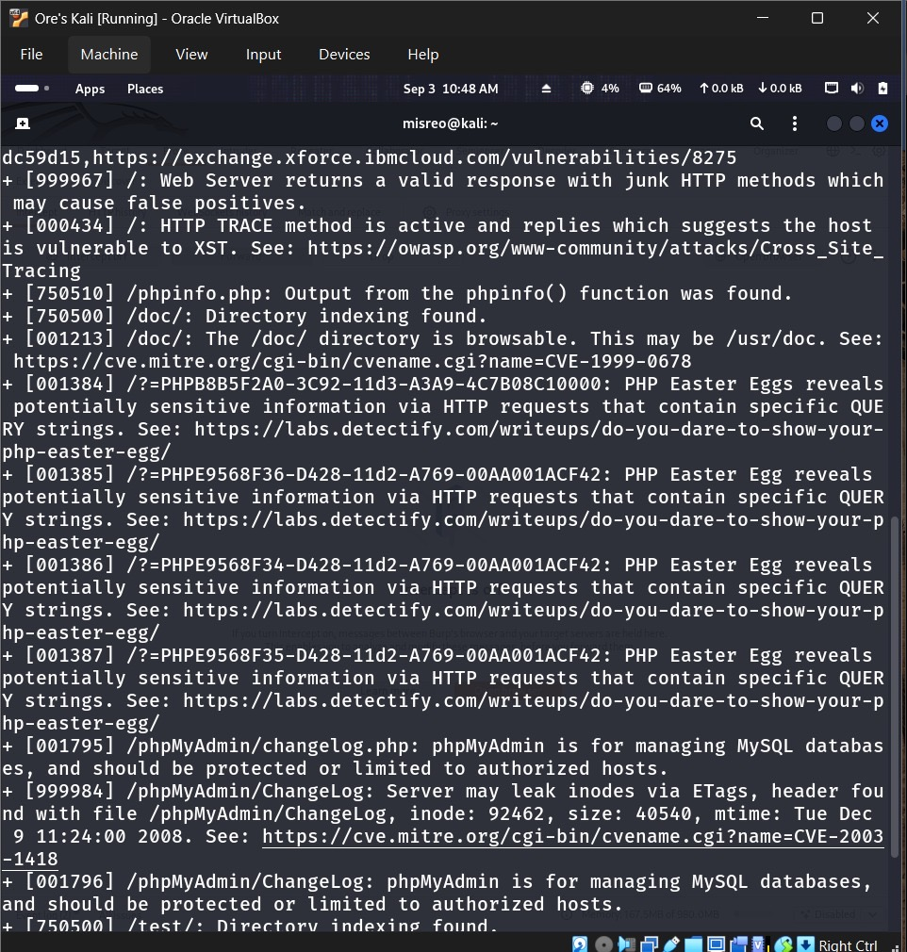
Figure 12. TRACE, phpinfo and directory-listing findings.
Further down: the TRACE method enabled, phpinfo() reachable, directory indexing switched on, and phpMyAdmin-related content sitting there.
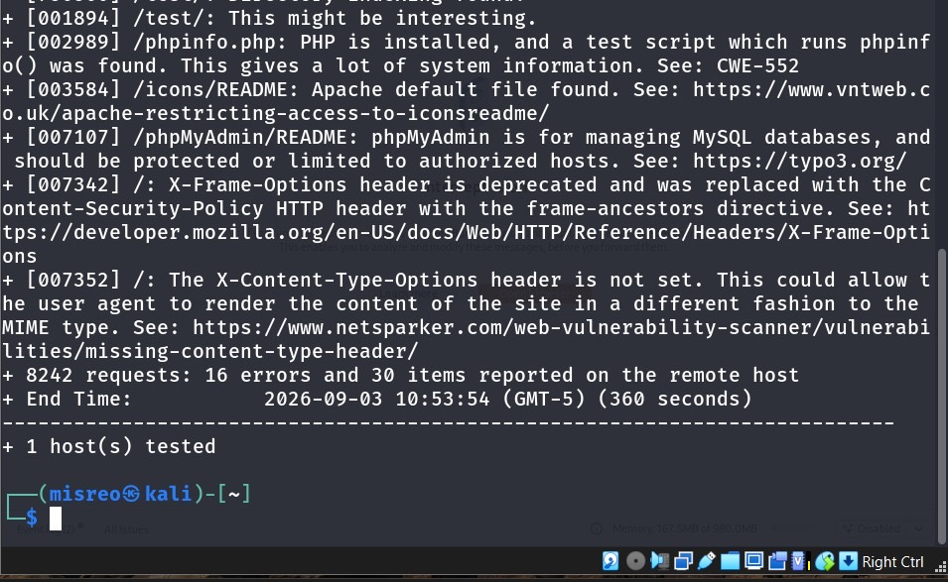
Figure 13. Nikto completion summary.
By the time it finished, Nikto had sent 8,242 requests and come back with 30 findings, one of them being the missing X-Content-Type-Options header.
Five of those findings are worth pulling out specifically:
Finding | What it means, and the fix
Outdated Apache/PHP | Old enough that known bugs could still be sitting in it. Get it onto a supported release and keep it patched.
HTTP TRACE enabled | Not normally needed, and it can be abused for cross-site tracing tricks. Turn it off unless there's a specific reason to keep it.
Directory indexing on | Basically hands out a file listing to anyone who asks. Disable indexing and lock down directory access.
phpinfo.php reachable | Dumps a lot of configuration detail an attacker could use. Remove the page, or restrict it tightly.
Missing security headers | Without CSP, nosniff, Referrer-Policy and Permissions-Policy, the browser has less to fall back on when something does go wrong. Add the missing headers.

4. DIRB Content Discovery
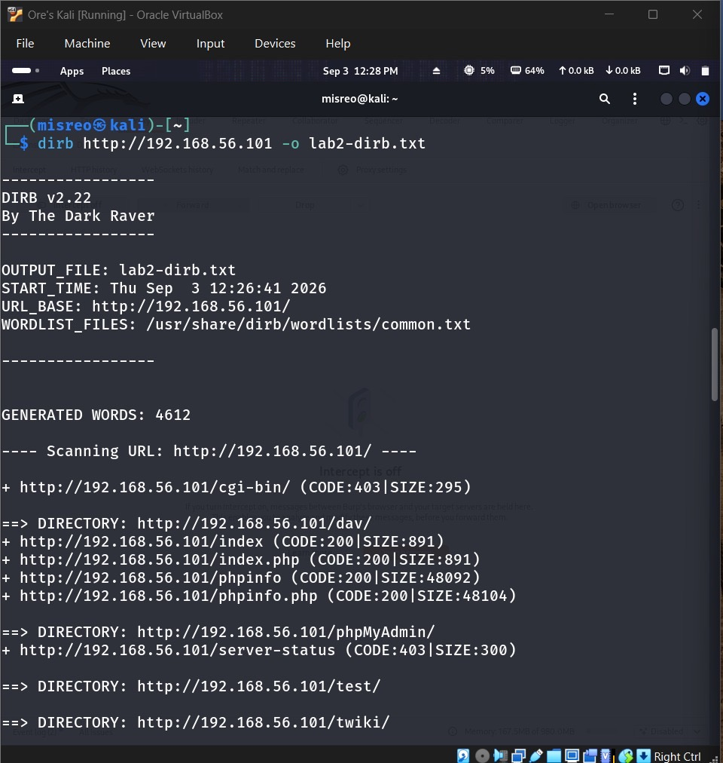
Figure 14. DIRB discovered paths and status codes.
DIRB dug up a batch of paths — /dav/, /phpMyAdmin/, /test/, /twiki/, a phpinfo file, and a server-status endpoint that turned out to be protected.
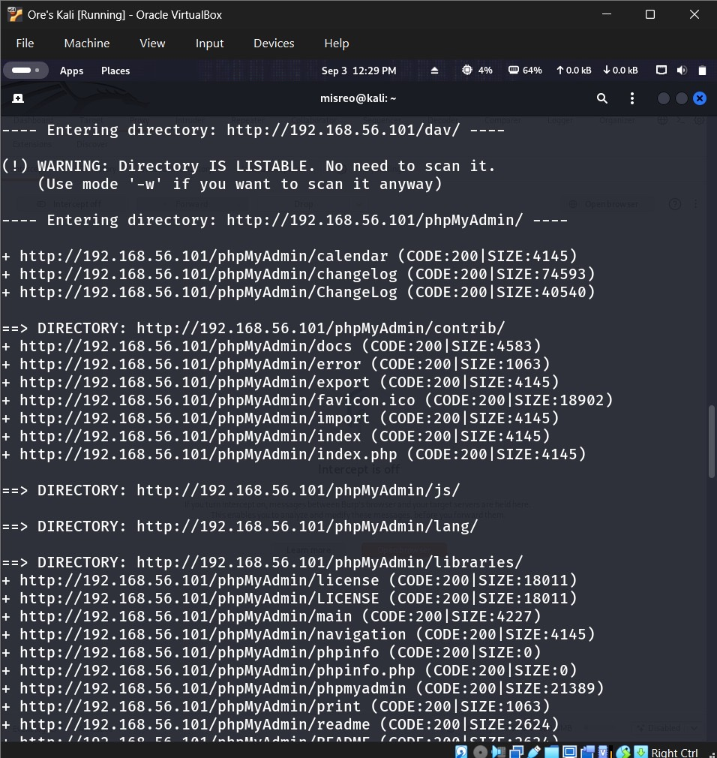
Figure 15. phpMyAdmin content enumeration.
It also broke into the phpMyAdmin directory and listed several files and subfolders inside — more than I expected, honestly.
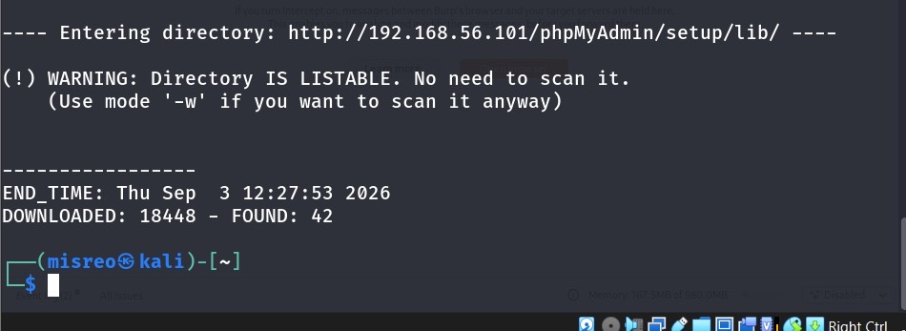
Figure 16. DIRB completion, 42 findings.
Once it wrapped up, DIRB had sent 18,448 requests and found 42 entries total. Directories you can just list like that make it a lot easier for someone to map out what's actually running on the server.
Path | Code | What it means
/index.php | 200 | Resource returned normally.
/phpMyAdmin/ | Directory | Admin interface is exposed.
/server-status | 403 | Exists, but access is blocked.
/test/ | Directory | Predictable test content is sitting there.
/twiki/ | Directory | Extra application surface I hadn't accounted for.
One thing I checked for specifically: whether DIRB would surface the upload folder on its own. It didn't list /dvwa/hackable/uploads/ in this particular run. That said, the upload test in Figures 6–10 already confirmed files land in a web-reachable spot, so a more targeted directory scan aimed at that exact path would probably still find it.

5. Mutillidae Baseline and Manual SQL Tests
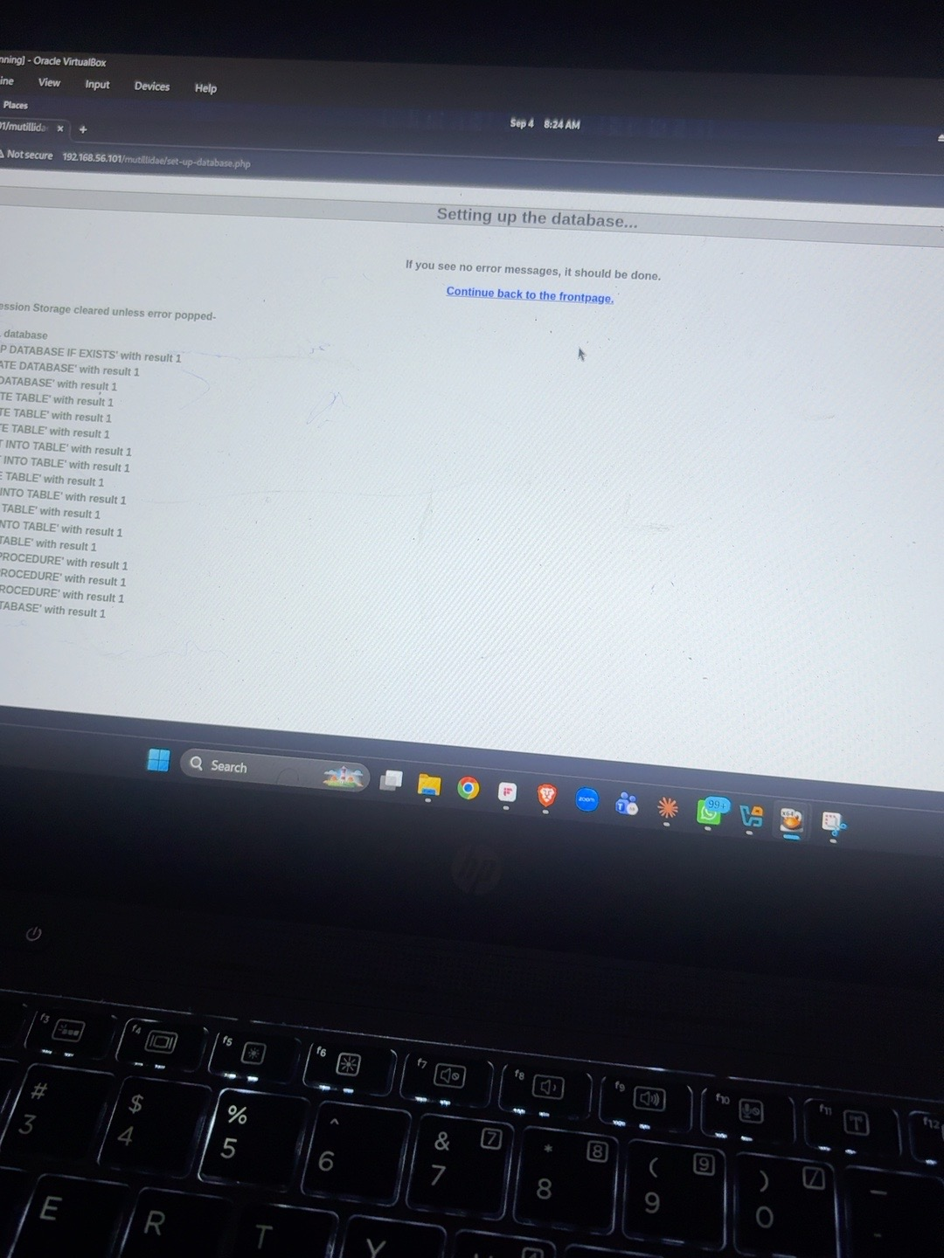
Figure 17. Mutillidae database setup completed.
The setup page confirmed the database and tables were built correctly. I'd hit a mismatch earlier where it was pointing at the wrong database, and switching it to owasp10 fixed that.

Mutillidae input map
Page / control | Parameter | Method | Normal value
Router | page | GET | user-info.php
View Account Details form | username | GET | admin
View Account Details form | password | GET | admin
Submit control | user-info-php-submit-button | GET | View Account Details

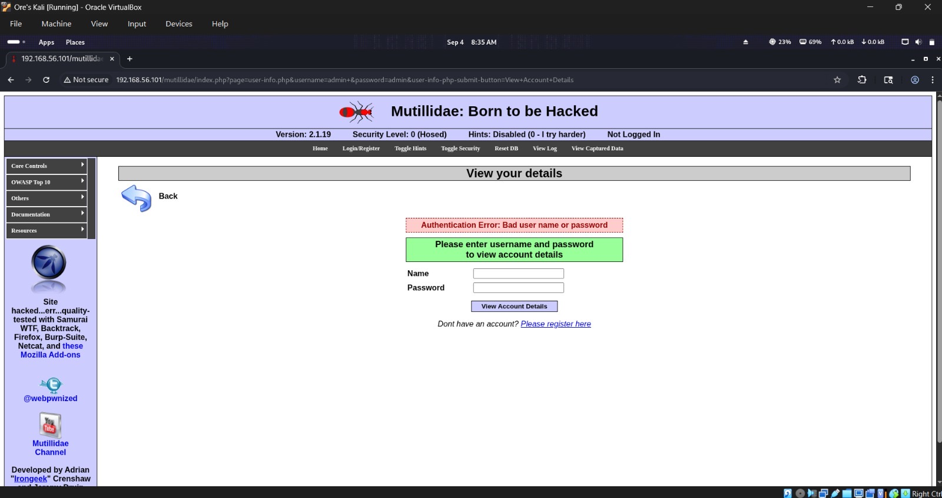
Figure 18. Normal authentication baseline.
A plain admin/admin submission returned the usual 'bad username or password' message — no more missing-table error, which told me the database connection was actually working now.
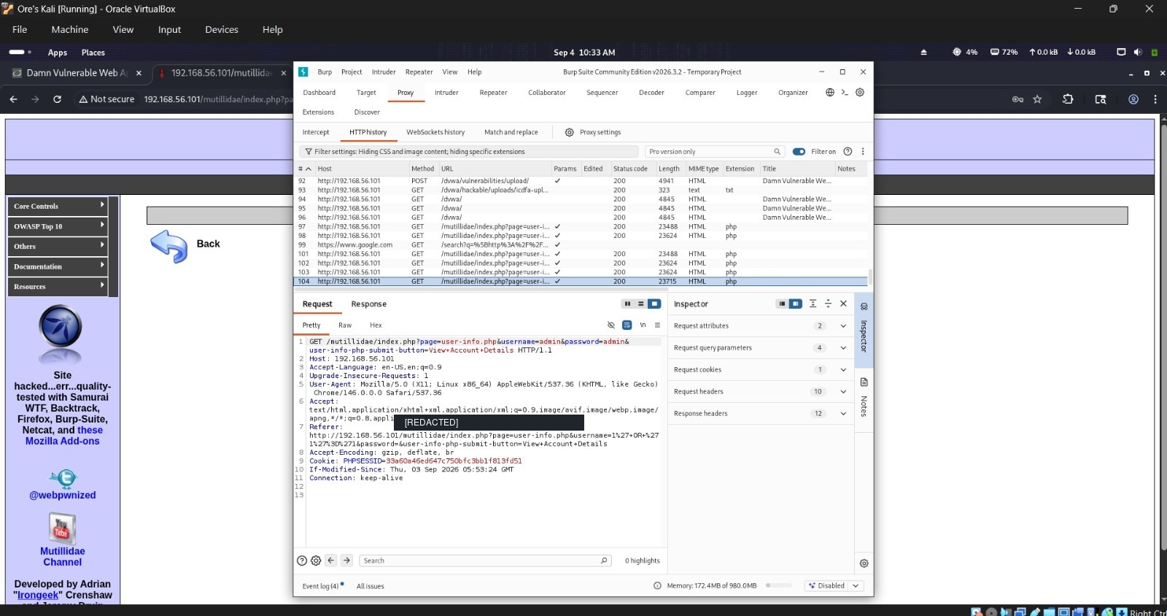
Figure 19. Normal baseline recorded in Burp's HTTP history.
Same request, caught in Burp's history — page=user-info.php, username=admin, password=admin, all visible in the GET request. PHPSESSID masked, as always.
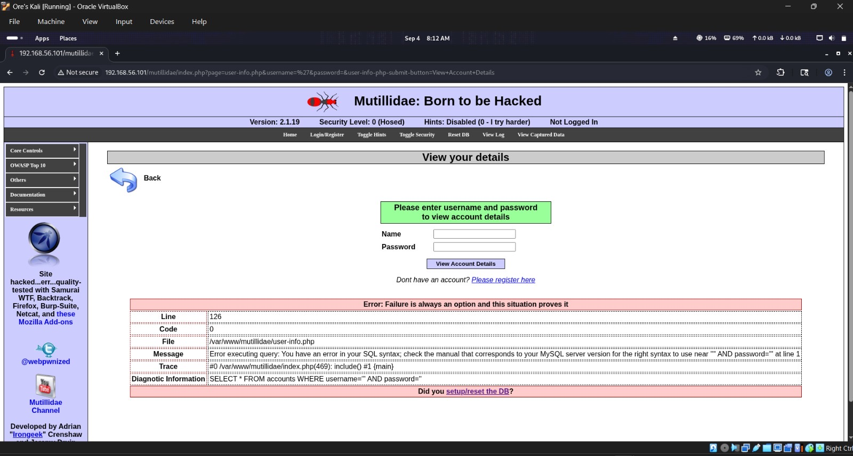
Figure 20. Single-quote input caused an SQL syntax error.
Dropping a single quote into the username field broke the query outright and threw a proper SQL syntax error — you can literally read the raw query in the error message, which really shouldn't be visible to a user.
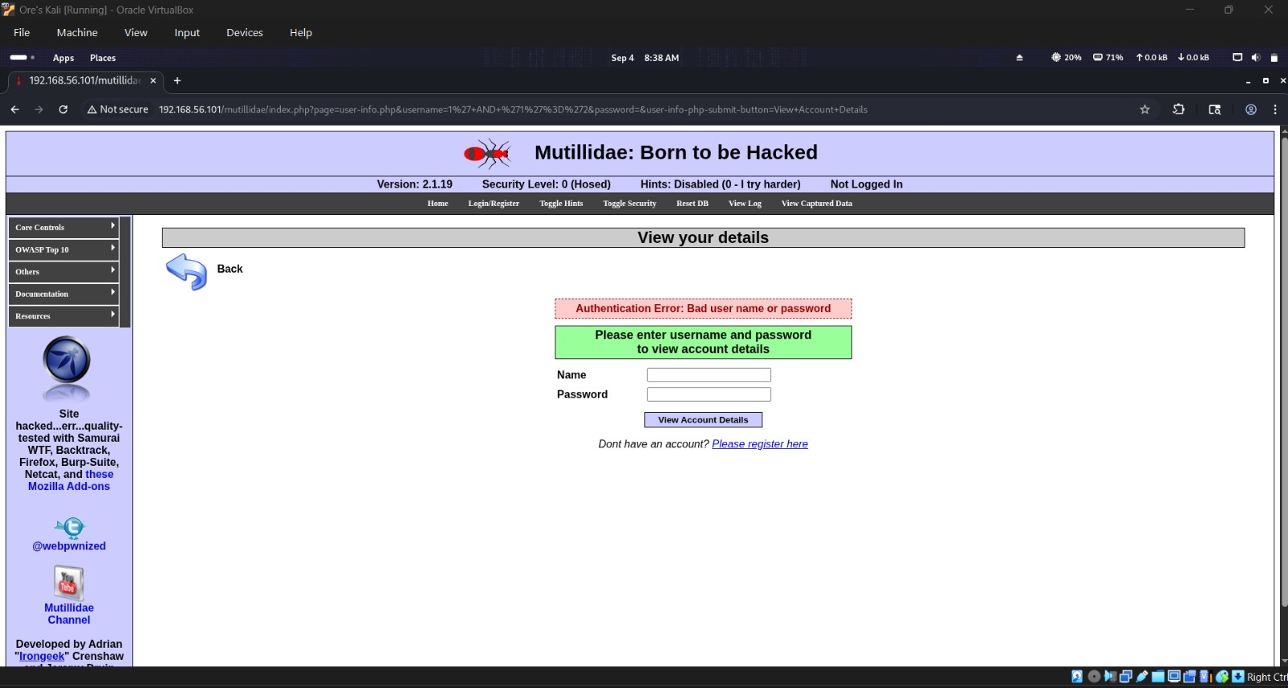
Figure 21. False boolean condition returned authentication failure.
The false condition, 1' AND '1'='2, came back with the same generic authentication failure — nothing unusual, which is exactly what the 'false' half of this comparison should look like.
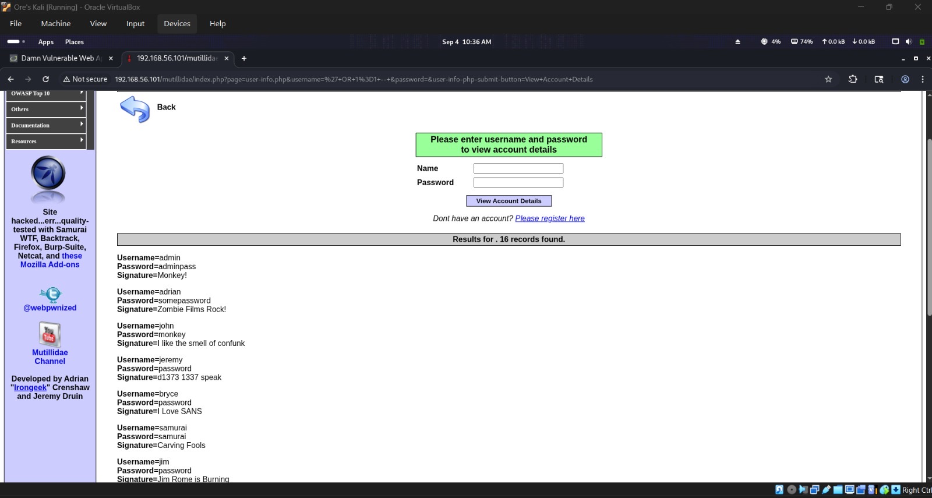
Figure 22. True-condition test returned 16 training records.
The true-condition version took a second attempt to get right. My first try with just ' OR '1'='1 didn't work — it still failed, because the application appends its own AND password='' clause to whatever gets submitted, and that trailing clause was still evaluating to false. Commenting out the rest of the query fixed it: 1' OR '1'='1'-- - returned 16 records straight out of the accounts table. I'm not printing the record contents here, just confirming the count.
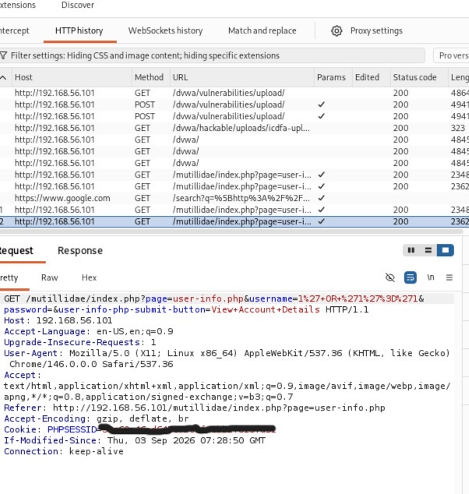
Figure 23. SQL-injection request recorded in Burp's HTTP history.
Burp also caught this exact request — the GET to /mutillidae/index.php with the tested username parameter is right there. Session value masked as usual.
So, side by side: 1' AND '1'='2 failed, as it should. ' OR 1=1 -- (properly commented) returned the 16 training records. The lesson is that an OR condition on its own can still fail if there's a trailing clause you haven't accounted for — the comment is what neutralizes that clause and lets the true predicate actually control the whole WHERE statement.

6. SQLMap Verification and Metadata Enumeration
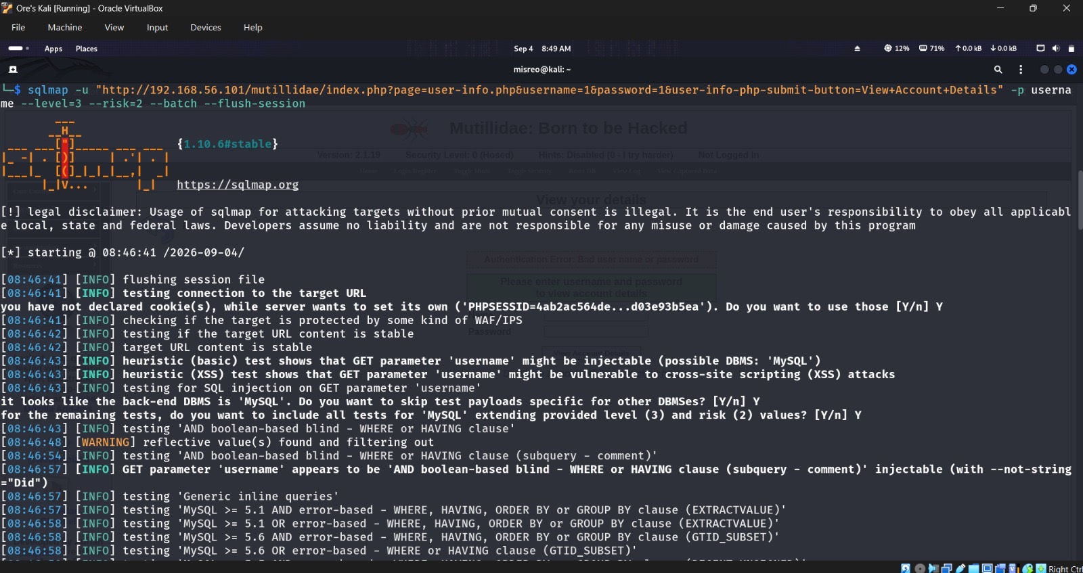
Figure 24. SQLMap flagged username as an injectable GET parameter.
Running SQLMap against the username parameter, it flagged MySQL as the likely backend fairly early and confirmed boolean-based behavior.
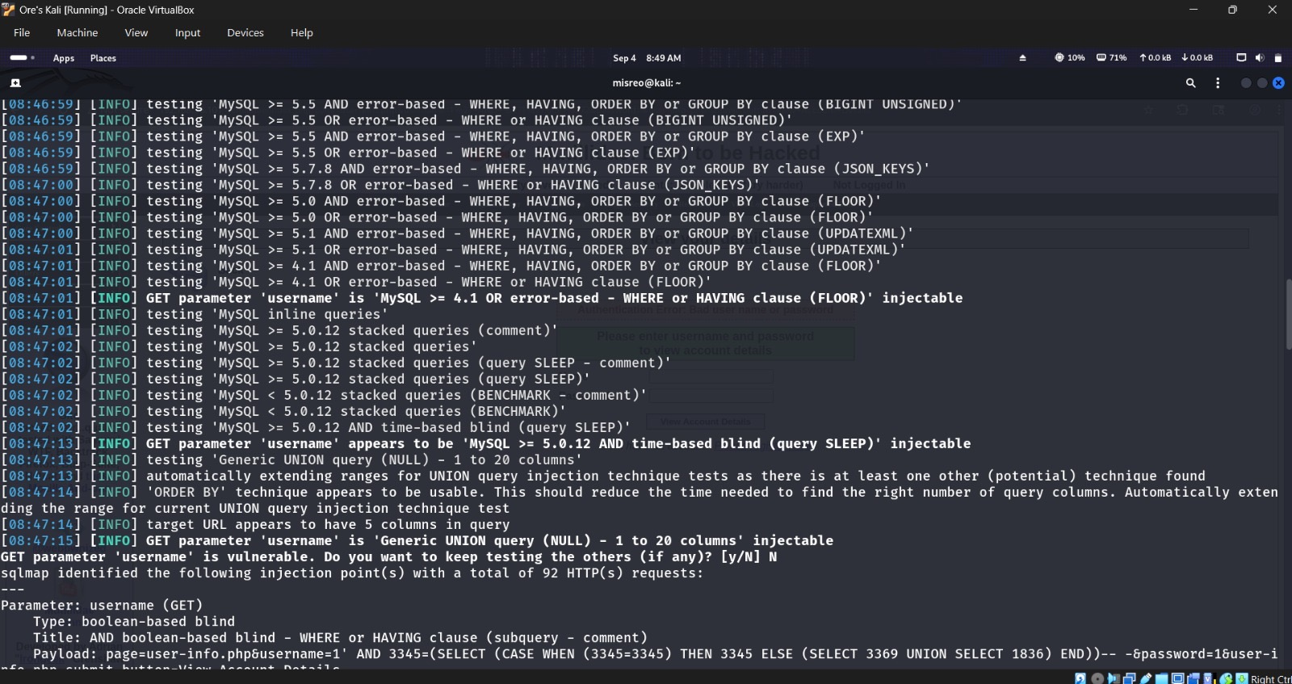
Figure 25. Multiple injection techniques verified.
By the end of the run it had verified four separate techniques on that same parameter: boolean-based blind, error-based, time-based blind, and a five-column UNION query.
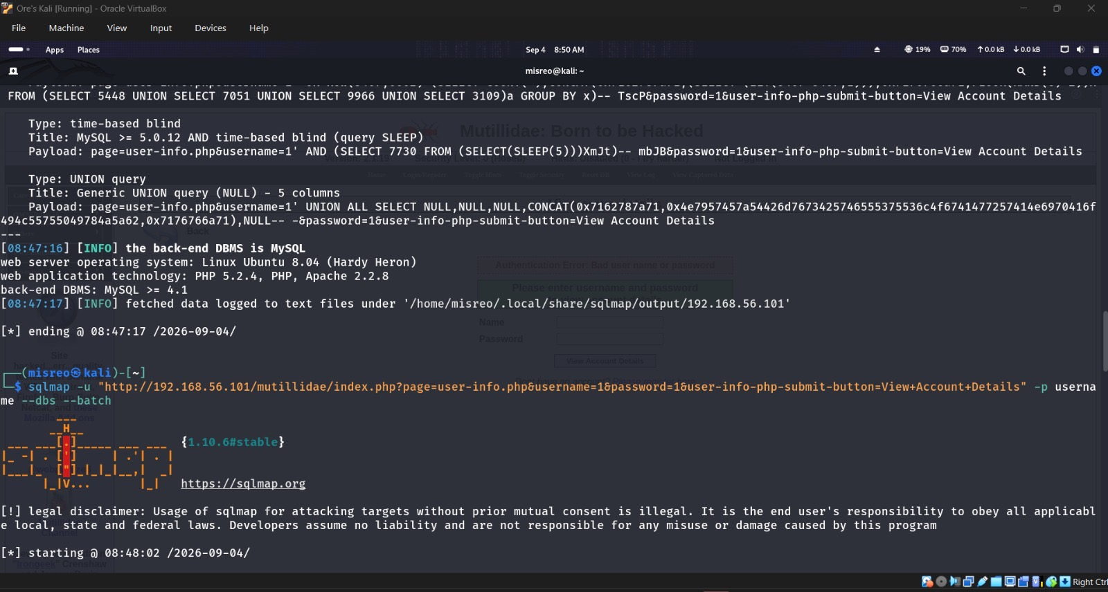
Figure 26. Backend DBMS and platform identified.
It also fingerprinted the stack underneath — MySQL 4.1+ running on Ubuntu 8.04 (Hardy Heron), with PHP 5.2.4 and Apache 2.2.8.
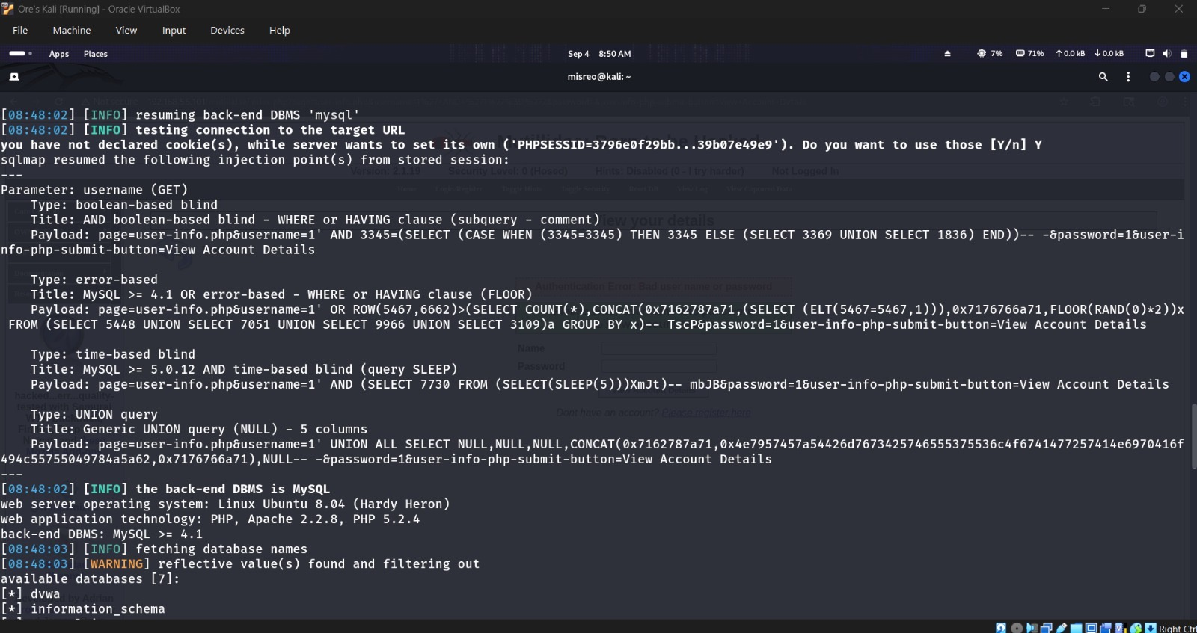
Figure 27. Database names enumerated.
Asking for database names with --dbs returned seven: dvwa, information_schema, metasploit, mysql, owasp10, tikiwiki, and tikiwiki195. Just names — no data pulled.
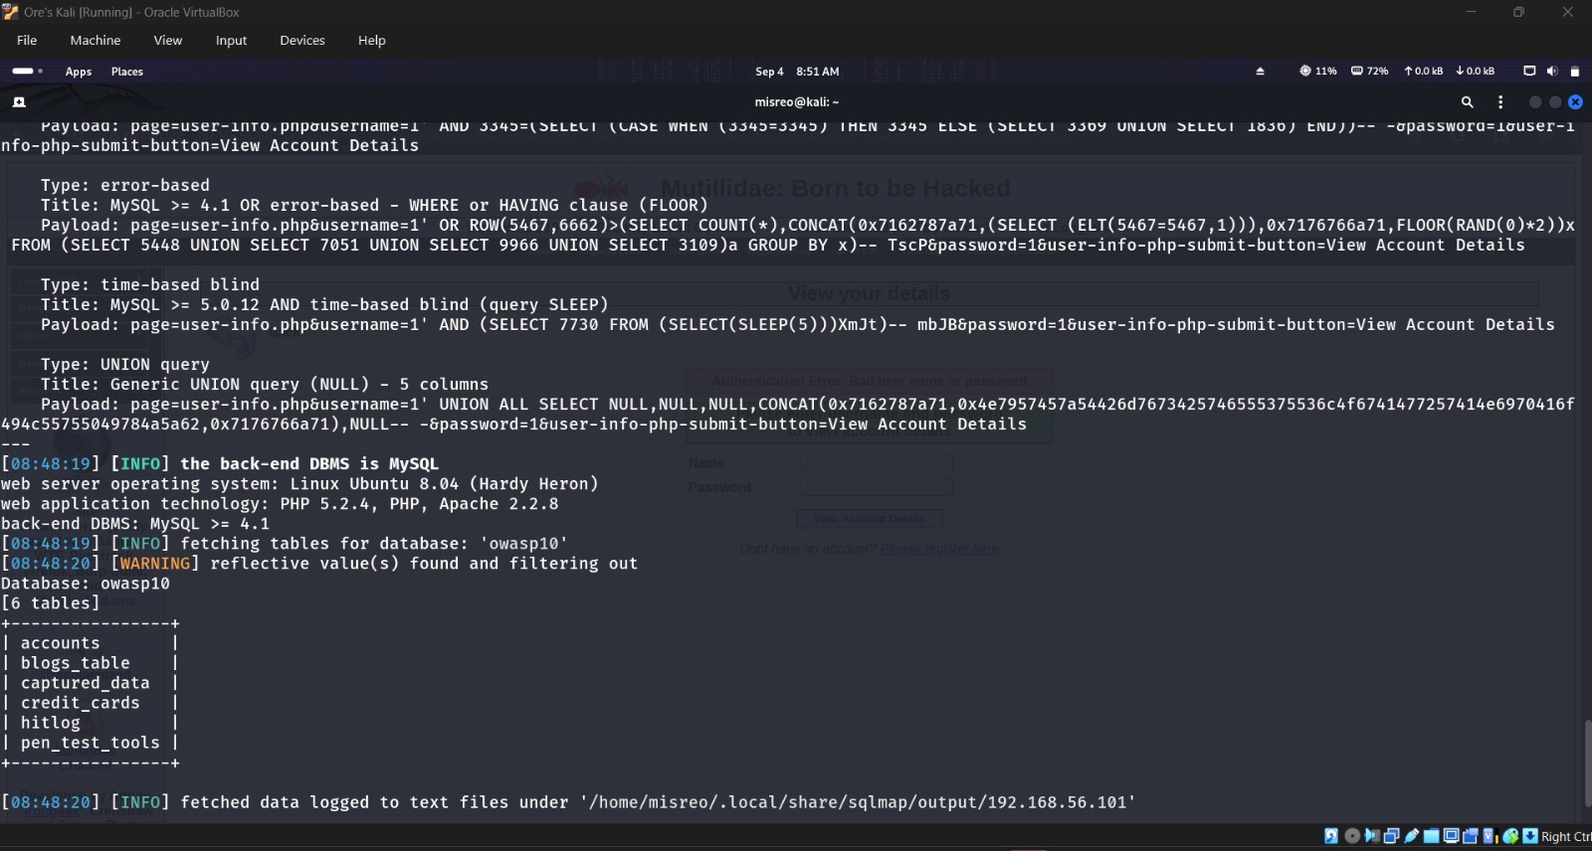
Figure 28. Tables in owasp10 enumerated.
--tables against owasp10 then listed six tables: accounts, blogs_table, captured_data, credit_cards, hitlog, and pen_test_tools. Structure only — nothing was dumped out of them.

7. Defensive Recommendations

Critical
- Use parameterized queries — bind every value that comes from the user instead of gluing it into the SQL string. This alone would have stopped the injection entirely.

High
- Tighten upload validation: check file signatures/content server-side, not just the extension or the client's Content-Type, and put a size limit on it.
- Keep uploaded files out of anywhere scripts can execute — store them outside the web root, or at minimum disable execution in that folder, and don't trust user-supplied filenames.
- Clear out the leftover admin/test content: remove phpinfo.php and the /test/ directory, and lock phpMyAdmin down by network and login.

Medium
- Stop returning verbose database errors to the user — log the details somewhere safe and show something generic instead.
- Patch Apache and PHP, and add the missing security headers.
- Trim the database account's privileges down to only what the application actually needs.

8. Student Questions
1. What is the difference between GET and POST?
GET usually pulls a resource and puts whatever parameters it needs right in the URL. POST sends its data in the body instead, which is why forms and uploads normally use it.
2. What is a parameter?
Just a named bit of input the app is expecting — something like username=1, where username is the parameter and 1 is the value.
3. Why should cookies be hidden in reports?
Because a valid session cookie can log someone in as you. If the value leaks while the session is still alive, whoever has it can just ride along as that user.
4. What is multipart/form-data?
The body format used for file uploads — it splits the request into separate parts, each with its own boundary, so form fields and file content don't get mixed together.
5. Why are extension and MIME type different?
The extension is just part of the filename; the MIME type is a label describing what kind of content is supposedly inside. Neither one actually proves what the file really contains.
6. Why is trusting client Content-Type weak?
Because the client sets that header, and a proxy like Burp can rewrite it in transit. The server has to check the real content itself instead of trusting a label someone else supplied.
7. Why store uploads outside an executable web directory?
So that even if something slips past validation, the web server can't actually execute it as code — it just sits there as a harmless file instead of becoming a script that runs.
8. What information did Nikto report?
Software versions, missing headers, enabled HTTP methods, leftover diagnostic files, whether directory listing is on, and any default or admin content still sitting around.
9. What do common DIRB codes mean?
200 means it found something and returned it; 301/302 means it's redirecting somewhere else; 403 means the thing exists but you're not allowed to see it; 404 means there's nothing there at all.
10. Why establish a baseline before SQL tests?
So you actually know what normal looks like — without that, you can't tell whether a strange response is because of your input or just how the app always behaves.
11. What happened with a single quote?
It broke the query structure completely and threw a raw MySQL syntax error back at me, which also happened to expose the actual query underneath.
12. How did the true and false conditions differ?
1' AND '1'='2 failed like it should. The working true-condition version, ' OR 1=1 -- (with the comment), returned 16 records — the comment is what made the difference, since it wipes out the trailing password check the app adds automatically.
13. What did SQLMap automate?
Pretty much everything I'd already found by hand, just automated and confirmed more thoroughly — it identified the injection type, worked out the backend DBMS, and pulled the database/table names for me instead of me guessing at each one.
14. Why do prepared statements stop SQL interpretation?
Because the query structure and the data are sent to the database separately, so whatever the user types is always treated as a value, never as part of the SQL itself — there's nothing left for an attacker's syntax to hijack.
15. Why is authorization mandatory?
Because testing without permission can expose real data, break something actually in use, or just be straight-up illegal — written authorization is what spells out exactly what's in bounds and what isn't.

Conclusion
Overall, this lab made it pretty clear how a handful of small weaknesses can stack up into a real problem. DVWA didn't care about file extensions or the MIME type it was told, and the uploads ended up sitting somewhere reachable straight from the browser. Nikto and DIRB between them exposed an outdated stack, permissive HTTP methods, diagnostic files, and predictable directories. And on the Mutillidae side, a single quote was enough to break the SQL query, with SQLMap later confirming multiple injection techniques on that same parameter — all while staying inside the metadata-only boundary the lab set. If there's one recurring theme across everything here, it's this: validate on the server, not the client; don't trust filenames, extensions, or Content-Type headers; and never build a SQL query by gluing strings together.

